

FS 3-way check

Functional Design Specification

Document Version Number: <Draft>

Page 1 of 7

Table of Contents

Table of Contents 2
1 Business Functionality Overview 4
1.1 Functional Specification Type 4
1.2 Business Functionality 4
1.3 Security Considerations 4
1.4 Business Dependencies 4
1.5 Business Criticality 4
1.6 Assumptions 4
1.7 Overall Business Flow Diagram 4
2 Reports 6
2.1 Report Title 6
2.2 Report Description 6
2.3 Timing and Frequency 6
2.4 Selection Screen 6
2.5 Processing Logic 6
2.6 Layout 6
2.7 Error Handling Specifications 6
3 Interfaces 7
3.1 Type of Interface 7
3.2 Process / Data Flow Diagram 7
3.3 Sending and receiving systems involved (applications) 7
3.3.1 Sending system 7
3.3.1.1 Development and Test Servers 7
3.3.1.2 Production Server 7
3.3.1.3 Source Message structure: 7
<Filed names with Hierarchy> 7
3.3.2 Receiving system 7
3.3.2.1 Development and Test Servers 7
3.3.2.2 Production Server 8
3.3.2.3 : Target Message structure 8
<Filed names with Hierarchy> 8
3.4 Frequency and Volume 8
3.5 Logical Data Element Mapping 8
3.6 Trigger 8
3.7 Dependencies 8
3.8 Error Management and Data Recovery Specifications 8
4 Enhancements 9
4.1 Process Flow Diagram 9
4.2 Enhancement Specifications 9
4.2.1 Trigger the 3way check 9
4.2.2 3 Way check pre-validations and rules 9
4.2.2.1 3 Way check trigger rule 9
4.2.2.2 Configuration screens 10
4.2.2.3 Configuration fields 10
4.2.2.4 Screens versus Fields 11
4.2.2.5 Mandatory / optional fields 11
4.2.3 3 Way check screens 12
4.2.3.1 Populate field information for “A: Institutional Bag Label” 12
4.2.3.2 Populate field information for “B: Biospecimen Data Form” 13
4.2.3.3 Populate field information for “C: Hang Tag Label” 13
4.2.4 Check rules 14
4.2.5 Table for batch characteristics 15
4.2.6 Batch data characteristics – other values 16
4.3 Error Handling Specifications 17
5 Forms 17
5.1 Layout 17
5.1.1 Output Types 17
5.1.2 Fields and Field Logic 17
6 Workflows 18
6.1 Process / Data Flow Diagram 18
6.2 Frequency and Volume 18
6.3 Roles and Responsibilities 18
6.4 Error Management and Data Recovery Specifications 18
7 Related Documents 18
8 Document History 18
9 Appendix 18

Business Functionality Overview

Functional Specification Type

FS Type | Applicable
Reports
Interfaces
Enhancements | X
Forms
Workflows

<Mark the respective object type>

Business Functionality

For the process of Cell and Gene Therapy the goods receipt must have a check against specific forms that are part of the process. For this check, there will be 3 documents against which the system should perform the check, therefore this functionality is called the 3-Way check.

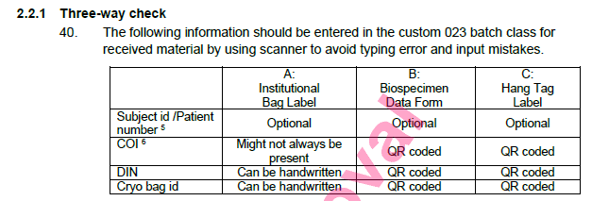

Security Considerations

<Provide the security object details and any other security considerations>

Business Dependencies

<Provide details of any business dependency on any other object development or business process >

Business Criticality

<Define the business criticality of this functionality>

Assumptions

<Provide the assumptions made in the design >

Overall Business Flow Diagram

- Posting goods receipt in MIGO
- System check paramenter table for 3 way check
- If true
- Checks material class if have forms / label pop-up information
- If true
- Checks parameter table for mandatory fields per material
- If true – system starts 3 way check and shows the user the following pop-up screens
- Populate fields information for “A: Institutional Bag Label”
- Populate field information for “B: Biospecimen Data Form”
- Populate field information for “C: Hang Tag Label”
- If false, system skips previous steps and continues normal Goods receipt
- Perform field comparison check
- If 3 way check passed
  - System posts information in custom local 023 batch characteristics has “3way check successful?” = “YES”
- If 3 way check rejected?
  - System posts information in custom local 023 batch characteristics has “3way check successful?” = “NO”

Final decision of stock is always to be made with the usage decision by QA

Reports

Report Title

Report Description

Timing and Frequency

weekly

Selection Screen

Display field name | Table | Field | Addition info

Processing Logic

Layout

DEsenho aqui dos popups

Error Handling Specifications

<Mention any specific error handling requirements, error logging etc>

Interfaces

Type of Interface

<Mention the type of interfaces such as ALE, IDOC, PROXY, XML, FTP etc.>

Process / Data Flow Diagram

<Flow diagram across systems and design details>

Sending and receiving systems involved (applications)

Sending system

Development and Test Servers

<Provide sender system details in development and test servers>
Source System | Eg : D10
Connecting protocol | Eg : IDOC , Proxy , RFC
Message format which will be transferred from source | Eg : IDOC xml
Security / Encryption requirement

Production Server

<Provide sender system details in production server>

Source System | Eg : P10
Connecting protocol | Eg : IDOC , Proxy , RFC
Message format which will be transferred from source | Eg : IDOC xml
Security / Encryption requirement

Source Message structure:

<Filed names with Hierarchy>

No. | Pos. | Field Name | Field Description | Field length | Comments

Receiving system

Development and Test Servers

<Provide receiver system details in development and test servers>

Target System | Eg : MES
Connecting protocol | Eg : Web services
Message format which will be transferred from source | Eg : flat file , EDI
Security / Encryption requirement

Production Server

<Provide receiver system details in production server>
Target System | Eg : MES
Connecting protocol | Eg : Web services
Message format which will be transferred from source | Eg : flat file , EDI
Security / Encryption requirement

: Target Message structure

<Filed names with Hierarchy>

No. | Pos. | Field Name | Field Description | Field length | Comments

Frequency and Volume

<Mention the frequency of run and the volume of data>

Logical Data Element Mapping

< Provide the mapping excel sheet which maps the source(Sap fields in case of outbound) and target fields(Sap fields in case of inbound)>

Trigger

<Describe what is the trigger of the interface. For instance: trigger program, batch job, transaction…>

Dependencies

<Mention the dependencies on the objects or business process>

Error Management and Data Recovery Specifications

< Workaround for error scenarios. Manual retrigger or automatic retrigger after data correction

Enhancements

Process Flow Diagram

Enhancement Specifications

Trigger the 3way check

The trigger for the 3way check should be when saving the goods receipt using MIGO.

The enhancement should be triggered
- When the user saves a goods receipt in MIGO.

3 Way check pre-validations and rules

3 Way check trigger rule

The following fields are relevant and need to be retrieved upon saving MIGO to perform the check:

Field Name | Data element | Retrieving logic
Purchasing Organization | EKKO-EKORG | Field can be found from the purchase order that the user is populating. MSEG-EBELN
Material type | MARA-MTART | Field can be found from the MSEG-MATNR to find MARA-MTART
Characteristic value for “Hazardous class” | ATWRT | For MSEG-MATNR, RCTAV-ATNAM=NL_HAZARDOUS_CLASS

The 3-way check process is triggered if conditions 1 and 2 and 3 are met:
- Purchase Organization: “0037” or “0035”
- Material type: “CSTM”
- Characteristic value for “Hazardous class” is 08

These conditions are maintained in the ZVV_PARAM table as below:
Lookup-Name (LOOKUP_NAME) | Freely Def. Key (FREE_KEY) | Free key Value (FREE_KEY_VALUE) | Indicator (INDICATOR1) | Value 1 (ZVV_PARAM- VALUE1)
ZCOI_3WAYCHECK | PORG | EKORG | x | 0035, 0037
ZCOI_3WAYCHECK | MATTYPE | MTART | x | CSTM
ZCOI_3WAYCHECK | ATWRT | NL_HAZARDOUS_CLASS | x | 08

If the previous checks are true, show the following message to the user

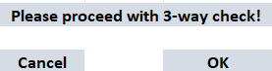

If the user presses Cancel the system should show the following message:

"Do you wish to cancel Goods Receipt process?"

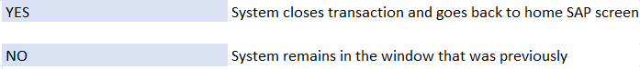

If the user clicks OK the system will check if there will be a 2-way check (exception) or a 3-way check. This is because to the “receiving label” is not always present when performing the goods receipt.

In order to achieve this and to guarantee a scalable solution to more than 3 form checks, we will have to build the solution with the following rules:

Configuration screens

A new table ZMM_3WAYSCREEN will be created as the first validation of the popup screens for our check.

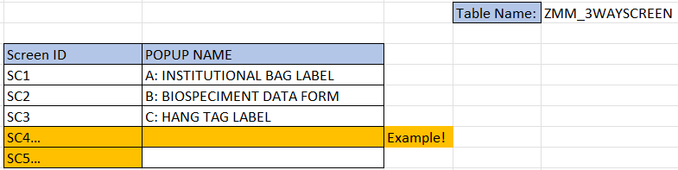

This table allows as many screens as the user would want and it to have and it will be possible to maintain this info via SM30 t.code.

Configuration fields

A new table ZMM_3WAYFIELDS will be created as the validation of fields that will be included in this check.

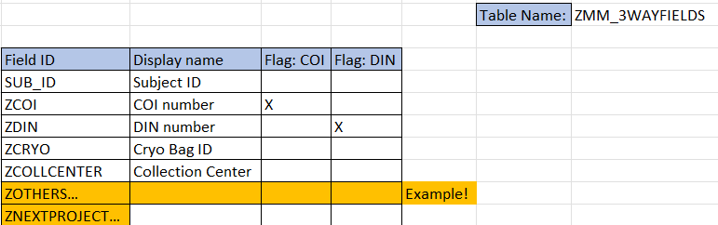

This table allows as many fields as the user would want, as can be seen in the orange line the example, and it to have and it will be possible to maintain this info via SM30 t.code.

Screens versus Fields

A new table ZMM_3WAYSCREENFIELDS will be created as the validation of fields that are to be shown for which screens during this check.

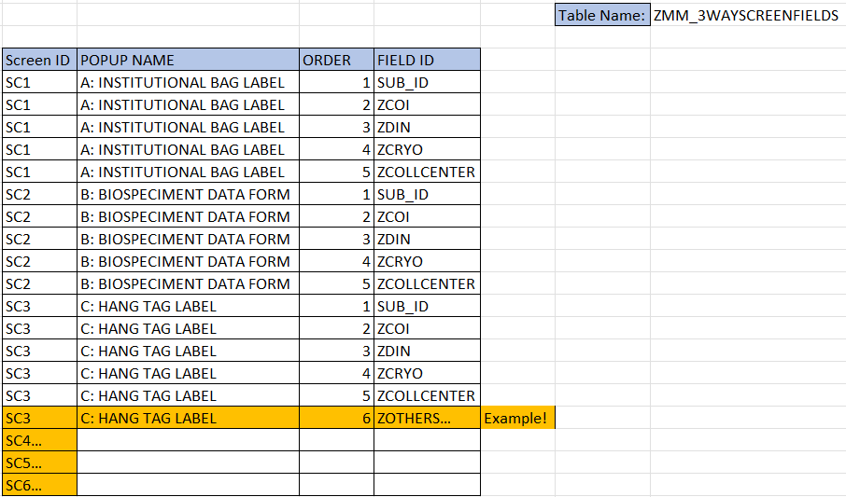

This table allows as many fields per screen as the user would want, as can be seen in the orange line the example, and it to have and it will be possible to maintain this info via SM30 t.code.

This would also mean that not all fields created in the previous table would have to be here. But in order to be available to populate here they have to be created in table ZMM_3WAYFIELDS. The same is applicable for the screens.

Mandatory / optional fields

The table below shows the fields that should be shown in the 3-way check popup screens and are derived from the material itself.

A new table ZMM_3WAYMATERIALSCREENFIELDS will be created as the validation of mandatory or optional fields that are to be shown for each screens during this check.

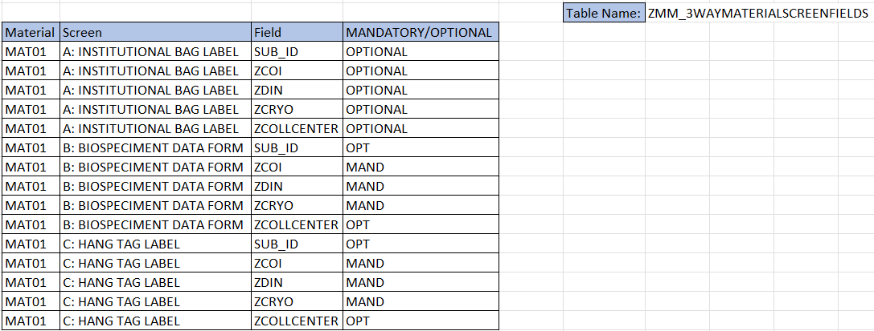

Check on how this would be updated. Tickets are usually a constraint.

This table allows the user to decided which fields are mandatory and which are optional. The fields should only appear here in case the previous tables are populated.

This table must be possible to maintain this info via SM30 t.code.

After these validations, the following screens will be shown to the user.

3 Way check screens

Populate field information for “A: Institutional Bag Label”

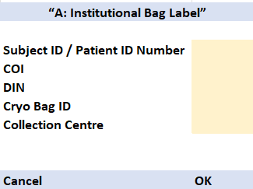

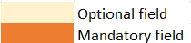

Both mandatory and optional fields should have the possibility of being populated manually, via barcode or via QR code.

These fields should have a length of 30 and should be alphanumeric.

Check if COI and DIN were already used

If COI was already used in another goods receipt, the system should show a message to the user “COI was already used in another process, continue?”

If DIN was already used in another goods receipt, the system should show a message to the user “DIN was already used in another process, continue?”

The way to check if these two fields are in use is to check in the batch characteristics as soon as the values are populated in the different screens.

This check should be performed to table ZQM_BATCHCOI. This table will consist of 4 fields and will have information regarding material, batch, COI and DIN.

Material + Batch + COI + DIN

The COI field will also be included in the batch characteristics of that specific batch.

Checksum for COI and DIN

Checksum should be optional and performed as long as the fields are populated. If not populated the checksum should not go forward.

These checks will be applicable for the remaining forms and inputs (B and C hang label).

This logic can be found in the following document

ST-028 ISBT 128 Standard Chain of Identity (CoI) Identifier (sharepoint.com)

Once the user finishes this screen, and clicks OK, the system should show the following screen:

Populate field information for “B: Biospecimen Data Form”

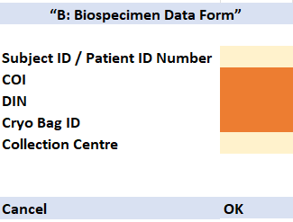

CANCEL – Same as initial screen and cancels the whole goods receipt process.

OK – If user is clicking OK but there is any mandatory field not populated the system should show the message

“Please populate all mandatory fields”

If all mandatory fields are populated, system shows next screen

Populate field information for “C: Hang Tag Label”

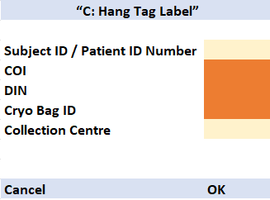

CANCEL – Same as initial screen and cancels the whole goods receipt process.

Check rules

If the user presses OK – System should now perform the 3-way check (or 2-way check). For this the system should compare the fields between screens that were just populated:

Example of check rules.

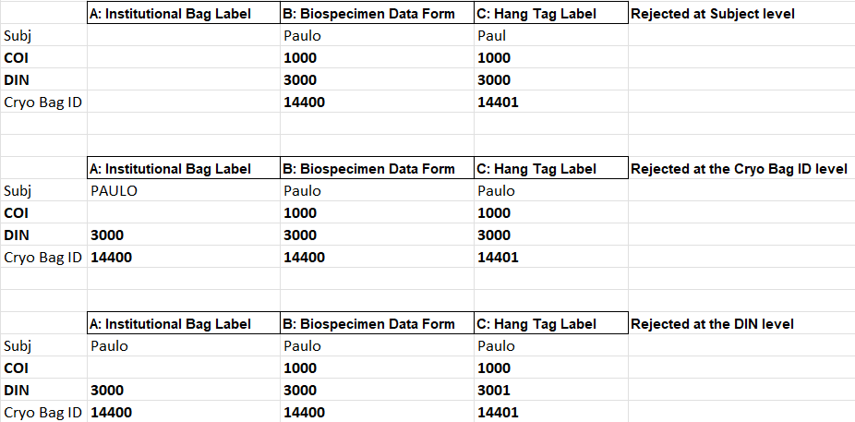

- Subject id/Patient number: This field is optional for all 3 checks, but if:
  - There is 1 populated or none the system should continue with the check.
  - There are 2 fields populated and information is the same, system should continue with the check.
  - There are at least 2 fields populated but the information is different, then the system should stop the check and show the message:

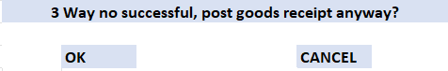

OK – Save goods receipt with quality inspection stock and save save ‘NO’ as the value of No. 11 in the table below and save the remaining information in the custom batch class 023. Final decision to be made with the usage decision by QA.

CANCEL – System should cancel the goods receipt
The continuation of the check, the system should do:

- COI for A vs COI for B vs COI for C <- The system goes forward with the check if the 3 are the same. If the 3 are not the same, COI for A must be blank but COI B and COI C must coincide. If this is true go forward to the next check, if not true, show same message as not true in previous check.

- DIN for A vs DIN for B vs DIN for C <- The system goes forward with the check if the 3 are the same. If the 3 are not the same, DIN for A must be blank but DIN B and DIN C must coincide. If this is true go forward to the next check, if not true, show same message as not true in previous check.

- Cryo bag ID A vs Cryo bag ID B vs Cryo bag ID C <- The system goes forward with the check if the 3 are the same. If the 3 are not the same, Cryo bag ID A must be blank but Cryo bag ID B and Cryo bag ID C must coincide. If this is true show the following message, if not true, show same message as not true in previous check:

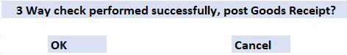

This means that the system doesn’t have to check the following field if the information populated for that field is not the same across screens / popups.

OK – System should proceed with the posting of goods receipt, save ‘YES’ as the value of No. 11 in the table below and save the following information in the custom batch class 023

Table for batch characteristics

No. | Patient Material Receipt Data Elements (Excluding  Sensitive Patient Data) | Value | Origin ? (Automatically read from tables or manual input?)
7a | COI Id from Biospecimen data form | String Value | Automatically by the system
7b | COI Id from Documentation Hangtag label | String Value | Automatically by the system
7c | COI Id from Documentation institutional bag label | String Value | Automatically by the system
8a | Patient ID/Subject number from Biospecimen data form | String Value | Automatically by the system
8b | Patient ID/Subject number from Hangtag label | String Value | Automatically by the system
8c | Patient ID/Subject number from institutional bag label | String Value | Automatically by the system
9a | Cryo bag id from Biospecimen data form | String Value | Automatically by the system
9b | Cryo bag id from Hangtag label | String Value | Automatically by the system
9c | Cryo bag id from institutional bag label | String Value | Automatically by the system
10a | DIN/Apheresis Number of Bag Hangtag label | String Value | Automatically by the system
10b | DIN/Apheresis Number of Bag Biospecimen data form | String Value | Automatically by the system
10c | DIN/Apheresis Number of Bag institutional bag label | String Value | Automatically by the system
11 | 3-way match successful? | Yes or No | Automatically by the system. Based on if the 3-way check was successful or not for that batch

and show message that the Goods receipt was performed successfully.

If the user presses CANCEL – System should show the following message:

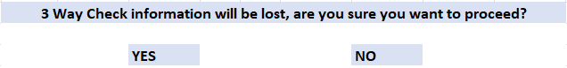

IF YES – System should cancel goods receipt and 3-way check information and go back to the SAP home screen

If NO – System cancels the Goods receipt and go back to SAP home screen.

Batch data characteristics – other values

In the GR of the patient material, information is collected and stored in SAP in the custom local 023 batch class. The class replaces the collection of information in MODA at GR.

Information that should be saved in batch class 023 can be found below:

No. | Patient Material Receipt Data Elements (Excluding  Sensitive Patient Data) | Value | Origin ? (Automatically read from tables or manual input?)
1 | Shipper Received | Date & Time
2 | Shipper Opened | Date & Time
3 | Is Shipper Intact? | Yes or No
4 | Receiving Location | String Value
5 | Number of Bags Received | String Value / numeric
6 | Receipt Complete | Date & Time
7a | COI Id from Biospecimen data form | String Value | Automatically by the system
7b | COI Id from Documentation Hangtag label | String Value | Automatically by the system
7c | COI Id from Documentation institutional bag label | String Value | Automatically by the system
8a | Patient ID/Subject number from Biospecimen data form | String Value | Automatically by the system
8b | Patient ID/Subject number from Hangtag label | String Value | Automatically by the system
8c | Patient ID/Subject number from institutional bag label | String Value | Automatically by the system
9a | Cryo bag id from Biospecimen data form | String Value | Automatically by the system
9b | Cryo bag id from Hangtag label | String Value | Automatically by the system
9c | Cryo bag id from institutional bag label | String Value | Automatically by the system
10a | DIN/Apheresis Number of Bag Hangtag label | String Value | Automatically by the system
10b | DIN/Apheresis Number of Bag Biospecimen data form | String Value | Automatically by the system
10c | DIN/Apheresis Number of Bag institutional bag label | String Value | Automatically by the system
11 | 3-way match successful? | Yes or No | Automatically by the system. Based on if the 3-way check was successful or not for that batch
12 | Is In-Transit Temperature Tracking Used? | Yes or No
13 | Collection Site Number Bag | String Value
14 | Collection Site Time Zone Bag | String Value
15 | Production Site Time Zone Bag | String Value
16 | Collection Date & Time of Bag | Date & Time
17 | Collection Date & Time (converted to CST Time Zone) Bag | Date & Time
18 | Any tissue anomalies identified for blood for Bag , i.e. fatty, opaque consistency? Abnormal Color? | Yes or No
19 | Temperature logger (Temptale) Serial Number | String Value
20 | Transit Temperature Lower Limit Specification | Numeric Value
21 | Transit Temperature Upper Limit Specification | Numeric Value
22 | Is Data Logger Temperature within Specifications? | Yes or No
23 | Is Data Logger Chart Trending within Specifications? | Yes or No Optional
24 | Human Immunodeficiency Virus, Types 1 and 2 Pass? | Yes or No
25 | Hepatitis B Pass? Yes or No | Yes or No
26 | Hepatitis C Pass? Yes or No | Yes or No
27 | Human T-Lymphotropic Virus, Type 1 and Type 2 Pass? | Yes or No

Description of requirement to create batch per bag
- Separate internal batch number should be created per bag to identify the bags
- individually.
- Batch numbers should be available after release for integration with MODA
- It should be possible to record the volume/weight of each bag separately
- Each bag should be able to be stored and delivered separately.
- Created batches should be linked to process order and final product.
- A possible solution is to use the by/co-product approach in the BOM/recipe

After this save is performed, the system will send the batch information to MODA. The details of this interface can be found in the:
ZBATMAS_MES_RW <- Batch master with classification. Updated when created (Already in place).
ZCLFMAS_MES <- Batch classification changes. Only for second messages, changes in batch classification.

Error Handling Specifications

<Various potential errors and handling of errors>

Forms

Layout

<VISIO diagram of required layout / or PDF format of required layout>

Output Types

<Custom output type created for the same or standard output type used>

Fields and Field Logic

<Define the field mapping and the field logic >

Workflows

Process / Data Flow Diagram

<Define the different steps and actions in detail – starting from triggering of workflow-to-workflow completion. Also mention the agent determination logic here>

Frequency and Volume

<Mention the frequency of run and the volume of transaction>

Roles and Responsibilities

<Define the different agents for each action and their responsibilities>

Error Management and Data Recovery Specifications

<Workaround in case of workflow error>

Related Documents
<Mention the related document names and respective path>

Dcoument Name | Document Path
<TS doc> | Path

Document History

Ver # | Date | Author | Brief Description of change
Draft | 30-Aug-2022 | Paulo Pimenta | 3 Way check for Project Alpha
0.1 | 30-Sept-2022 | Paulo Pimenta | 3 Way check for Project Alpha

Appendix

<Any supporting document to be added as appendix>

